ASSIGNMENT – 1

1.
Create a new S3 bucket in your AWS account with a unique name that includes your initials and the current date (e.g., mybucket-AB-20240618). Set the region to Asia Pacific (Mumbai).
ANS :
Steps:
- Open Amazon S3 in the AWS Management Console.
- Click Create bucket.
- Enter a unique bucket name including initials and date.
- Select Asia Pacific (Mumbai) – ap-south-1 as the region.
- Keep the default settings and click Create bucket.
- Verify that the bucket appears in the S3 bucket list.
Result:
S3 bucket was successfully created in the Mumbai (ap-south-1) region.
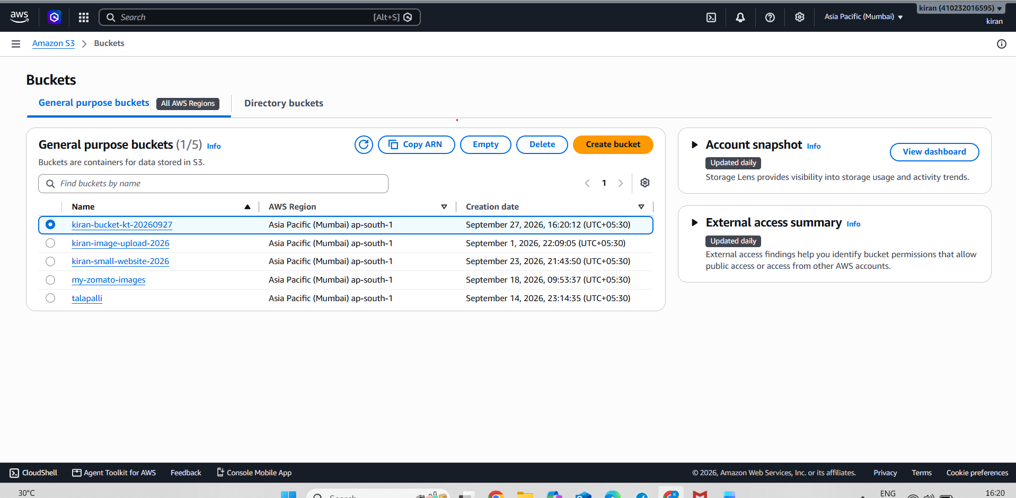

2.
Upload three different files (an image, a PDF, and a text file) to your new S3 bucket using the AWS Management Console. Make sure each file has a meaningful name related to your favorite app (e.g., instagram-logo.png, spotify-playlist.pdf, zomato-menu.txt).
ANS :
Steps:
- Open the AWS Management Console and navigate to Amazon S3.
- Open the S3 bucket created earlier.
- Create an image file named instagram-logo.png.
- Create a Word document containing Spotify playlist information.
- Convert the Word document into a PDF named spotify-playlist.pdf.
- Create a text file using Notepad and save it as zomato-menu.txt.
- In the S3 bucket, click Upload.
- Click Add files and select the three files:
  - instagram-logo.png
  - spotify-playlist.pdf
  - zomato-menu.txt
- Click Upload.
- Verify that all three files are displayed in the S3 bucket.

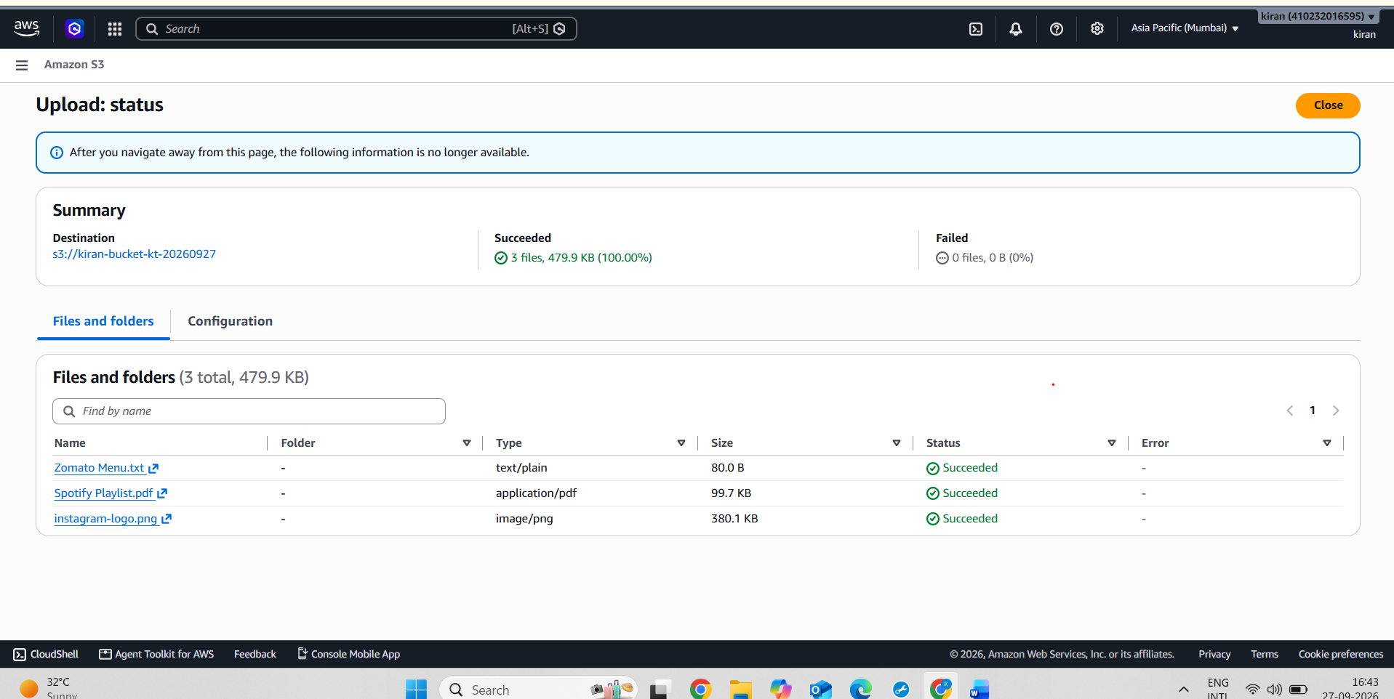

3.
Set the access permissions on one of your uploaded files so it is publicly accessible via a URL. Test the link in your browser to confirm it works.<br><br><em><strong>Hint:</strong> Use the 'Make public' option in the AWS S3 console and copy the object URL.</em>
ANS :
Steps:
- Open the AWS Management Console and go to Amazon S3.
- Open the bucket kiran-bucket-kt-20260927.
- Go to the Permissions tab and configure Block Public Access to allow public access to the required object.
- In the Bucket Policy section, add a policy that grants public GetObject permission to instagram-logo.png.
- Save the bucket policy.
- Open the instagram-logo.png object and copy its Object URL.
- Open the copied Object URL in a new browser or Incognito window.
- Verify that the image opens successfully without requiring AWS login.
Screenshot 1: Public Access settings.
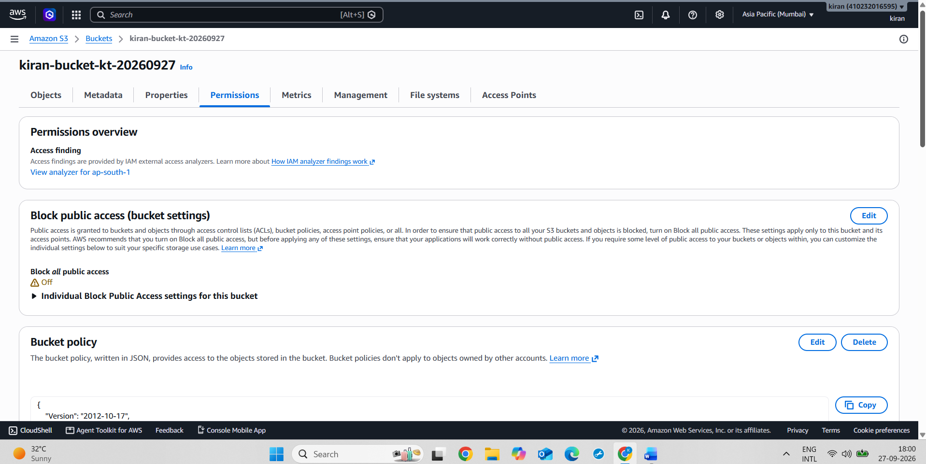
Screenshot 2: Bucket Policy.
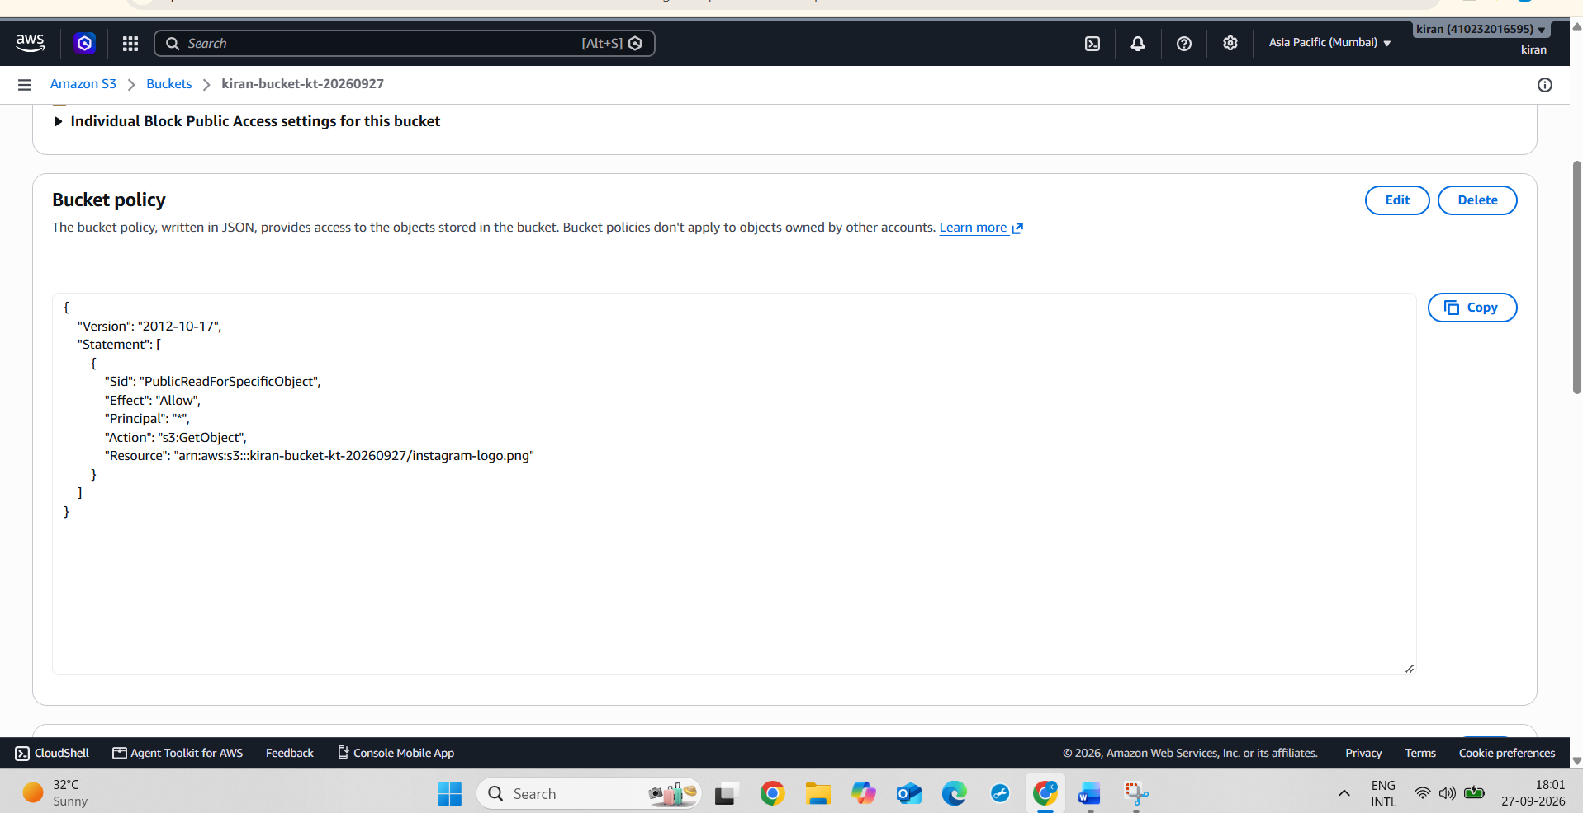
Screenshot 3:Instagram-logo.png opened through the public object URL in the browser.
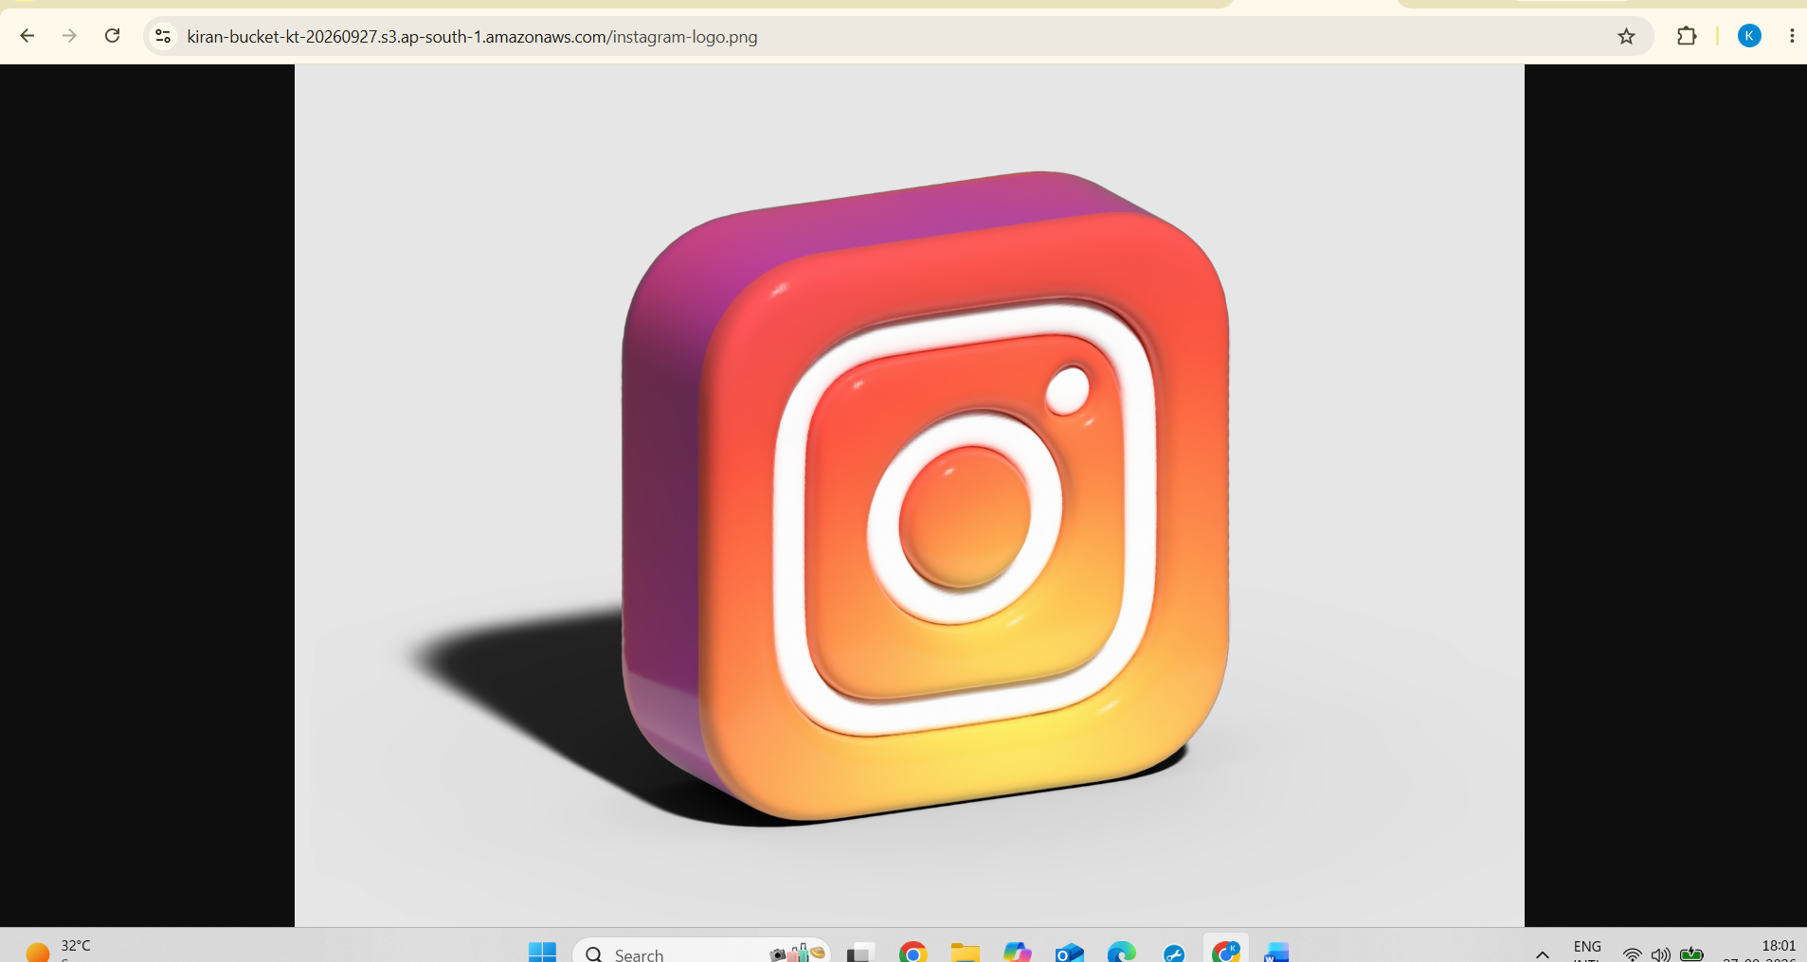

4.
Enable versioning on your S3 bucket, then upload a new version of one of your files (e.g., upload an updated zomato-menu.txt with different content). Check the version history to confirm both versions are stored.<br><br><em><strong>Hint:</strong> Use the 'Versions' tab in the bucket to view all versions.</em>
ANS :
Steps :
- Open the AWS Management Console and navigate to Amazon S3.
- Open the bucket kiran-bucket-kt-20260927.
- Go to the Properties tab and find Bucket Versioning.
- Click Edit, select Enable, and save the changes.
- Go to the Objects tab and locate the existing file Zomato Menu.txt.
- Create an updated copy of the file with different content, keeping the same filename (Zomato Menu.txt).
- Upload the updated Zomato Menu.txt file to the same S3 bucket.
- Since versioning is enabled, Amazon S3 stores the uploaded file as a new version while retaining the previous version.
- In the Objects tab, enable Show versions to view the version history.
- Verify that both versions of Zomato Menu.txt are displayed with their respective Version IDs and details.
Screenshot 1: Versioning enabled
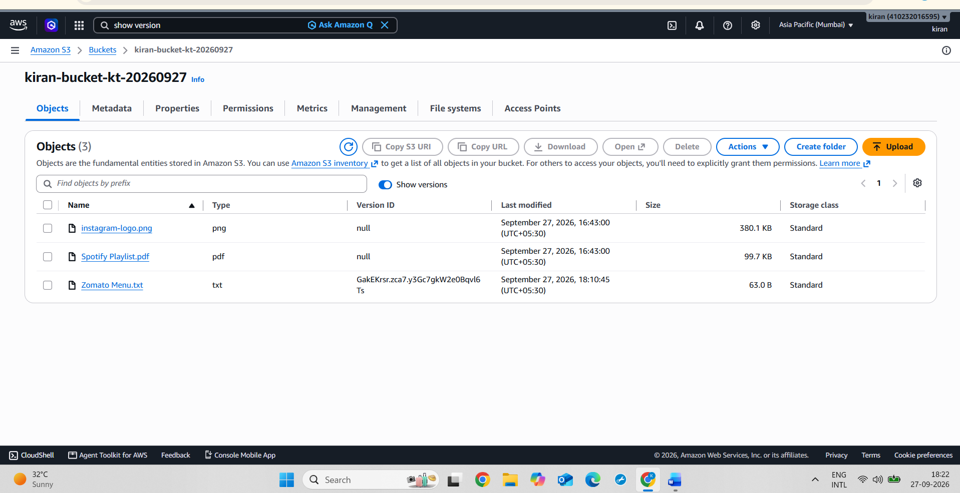
Screenshot 2: Upload of Updated File
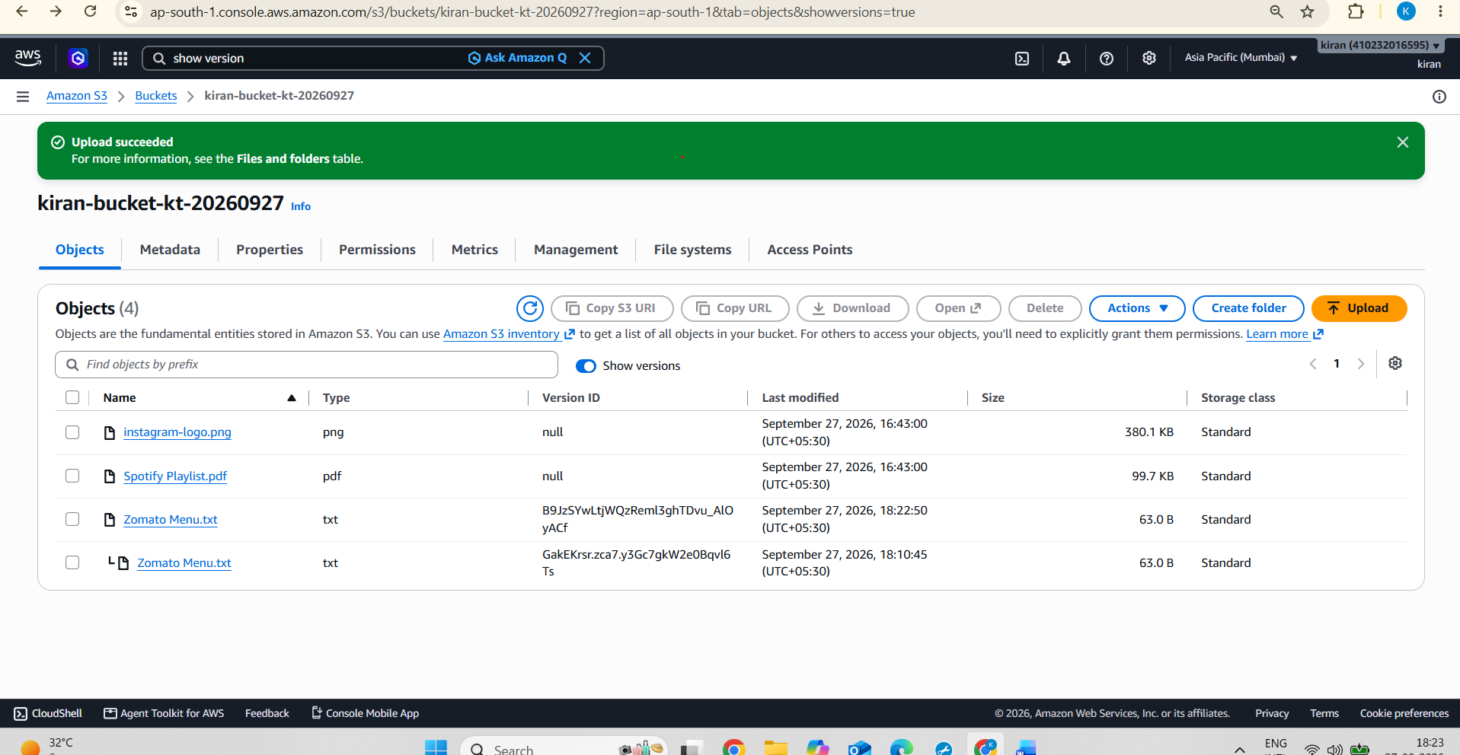
Screenshot 3: Version History
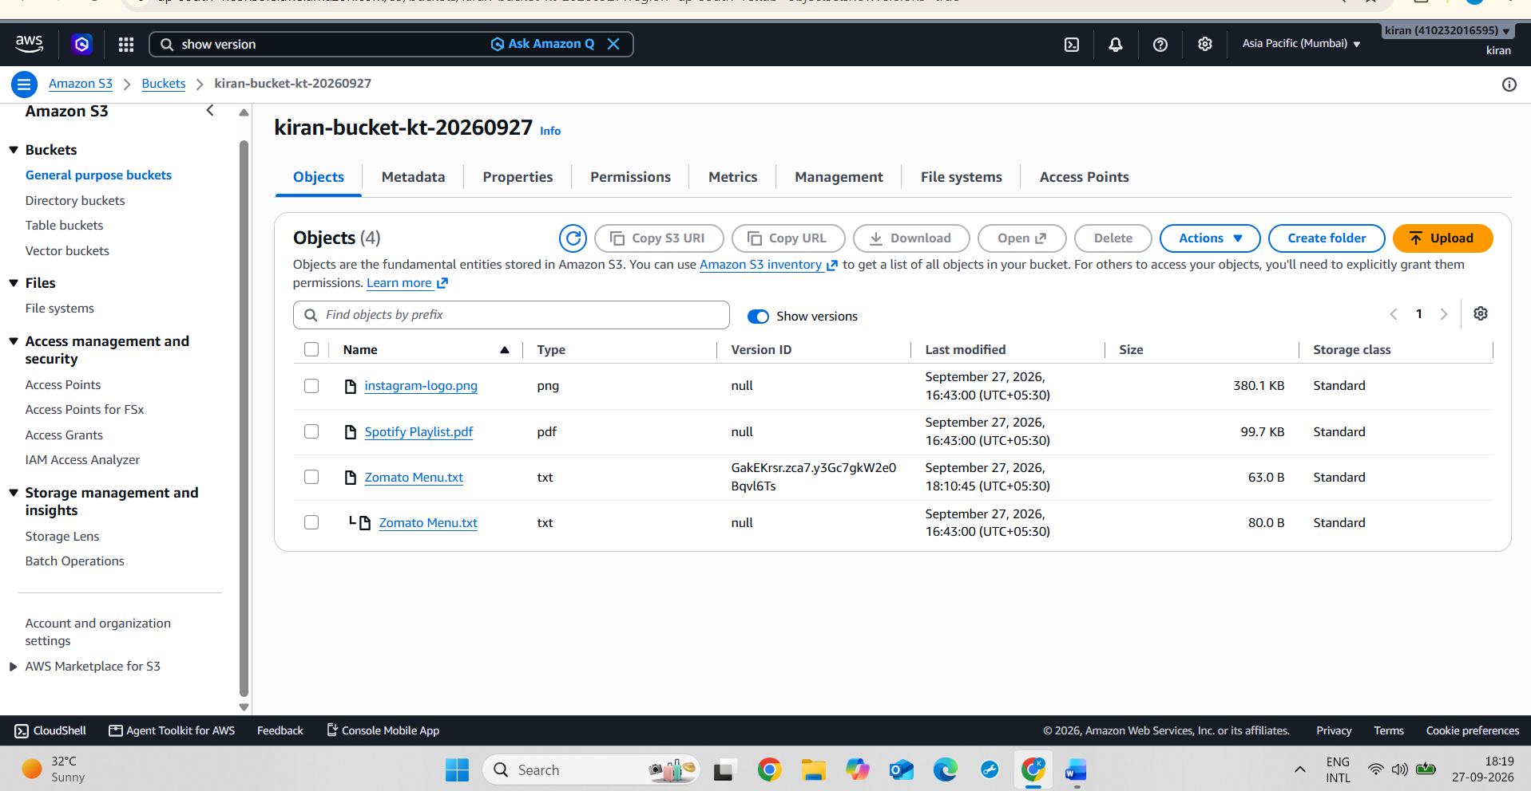
5.
Write a short comparison (3-4 sentences) explaining the main differences between AWS S3, EBS, and Glacier. Mention which one you would use for storing Instagram profile pictures, Flipkart order history, and old IRCTC booking records, and why.
ANS :
AWS S3 is an object storage service used to store files such as images, videos, and documents, while EBS provides block storage mainly for EC2 instances and applications that need a disk-like storage system.
S3 Glacier is designed for long-term archival of data that is rarely accessed, with lower storage costs but slower retrieval. For Instagram profile pictures, I would use S3 because the pictures need to be accessed frequently; for Flipkart order history, I would use S3 because the data needs reliable and convenient access; and for old IRCTC booking records, I would use S3 Glacier because old records may need to be retained for a long time and accessed less frequently.
Data | Storage | Reason
Instagram profile pictures | S3 | Frequently accessed images
Flipkart order History | S3 | Reliable storage with easy access
Old IRCTC booking records | S3 Glacier | Long-term, rarely accessed archival data

